**B and G Wind bearings replacement**

October 26, 2011 by [Erik](http://blog.oppedijk.com/author/oppedijk/)

The official B & G bearings for the wind angle and wind speed are quite expensive. Why not buy some 3rd party bearings for 10% of the original.[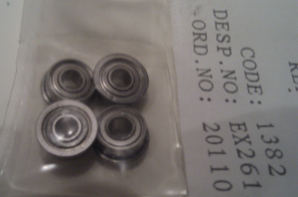](http://oppedijk.files.wordpress.com/2011/10/bearings.png)

These should match the 213 and 496 Masthead units for Brookes and Gatehouse. [Contact](mailto:bg@oppedijk.com) me for the exact bearing types to order.

Replacement is quite easy, remove the MHU from the mast, and there is one screw (secured behind a sticker) to remove to seperate the top and bottom parts. just replace the bearings and your windspeed sensor should work fine for a few more years.

[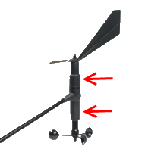](http://oppedijk.files.wordpress.com/2011/10/213mhu.png)For the 213 MHU, take a look at the picture to the left, the screws to open the unit are marked by the red arrows.

For the 496 unit, check out the pictures below (Thanks to JanW).

[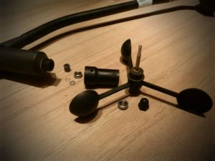](http://oppedijk.files.wordpress.com/2011/10/mhu496.jpg) [](http://oppedijk.files.wordpress.com/2011/10/mhu496_2.jpg)